- Row level security
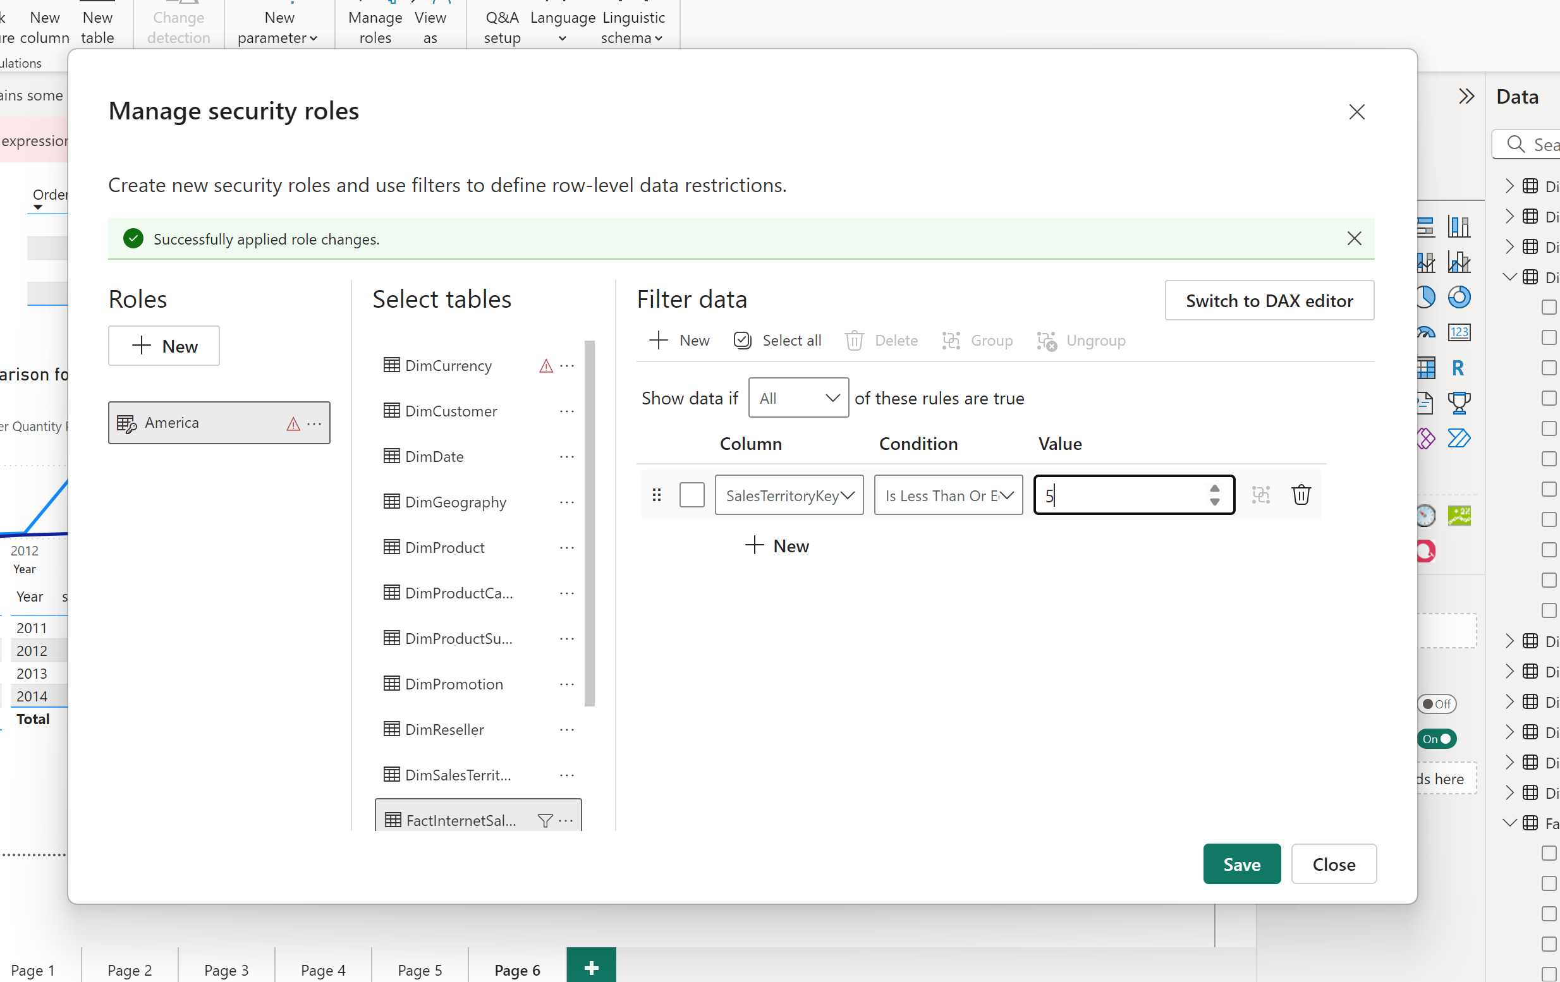

Adding row level security on fact internet sales to get America specific role, by only selecting Americas specific regions which are from one to five.
I added myself in row level secutriy in service
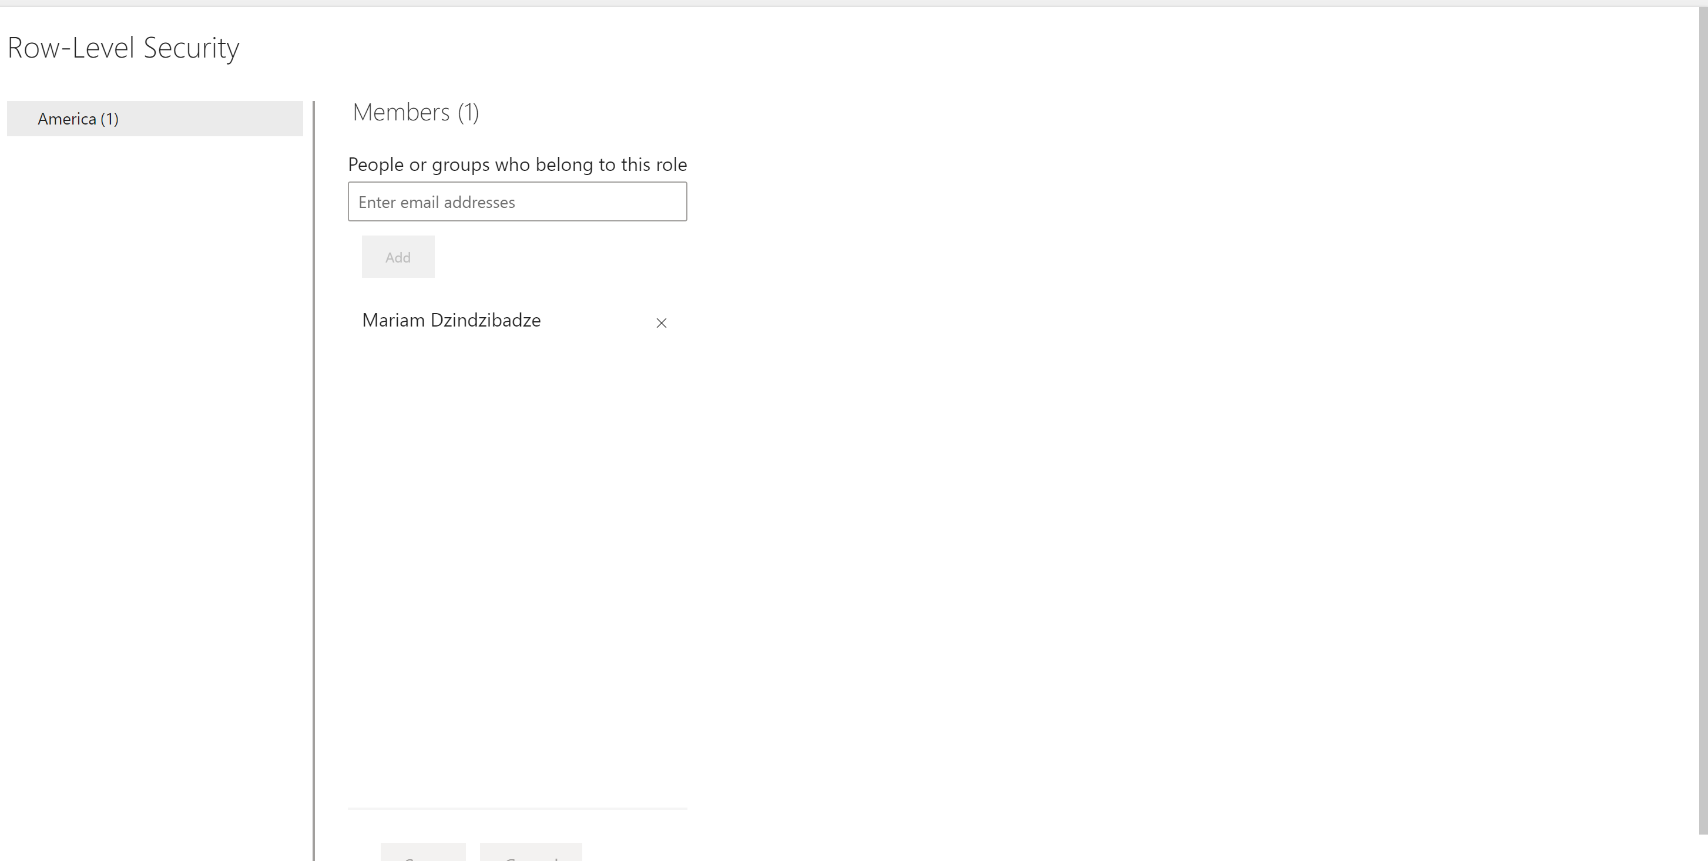

- Created bookmarks “Bar chart” and “Map visual” on the bar chart and on the map
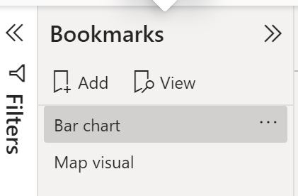
Then created buttons next to both that lead to opposite bookmarks
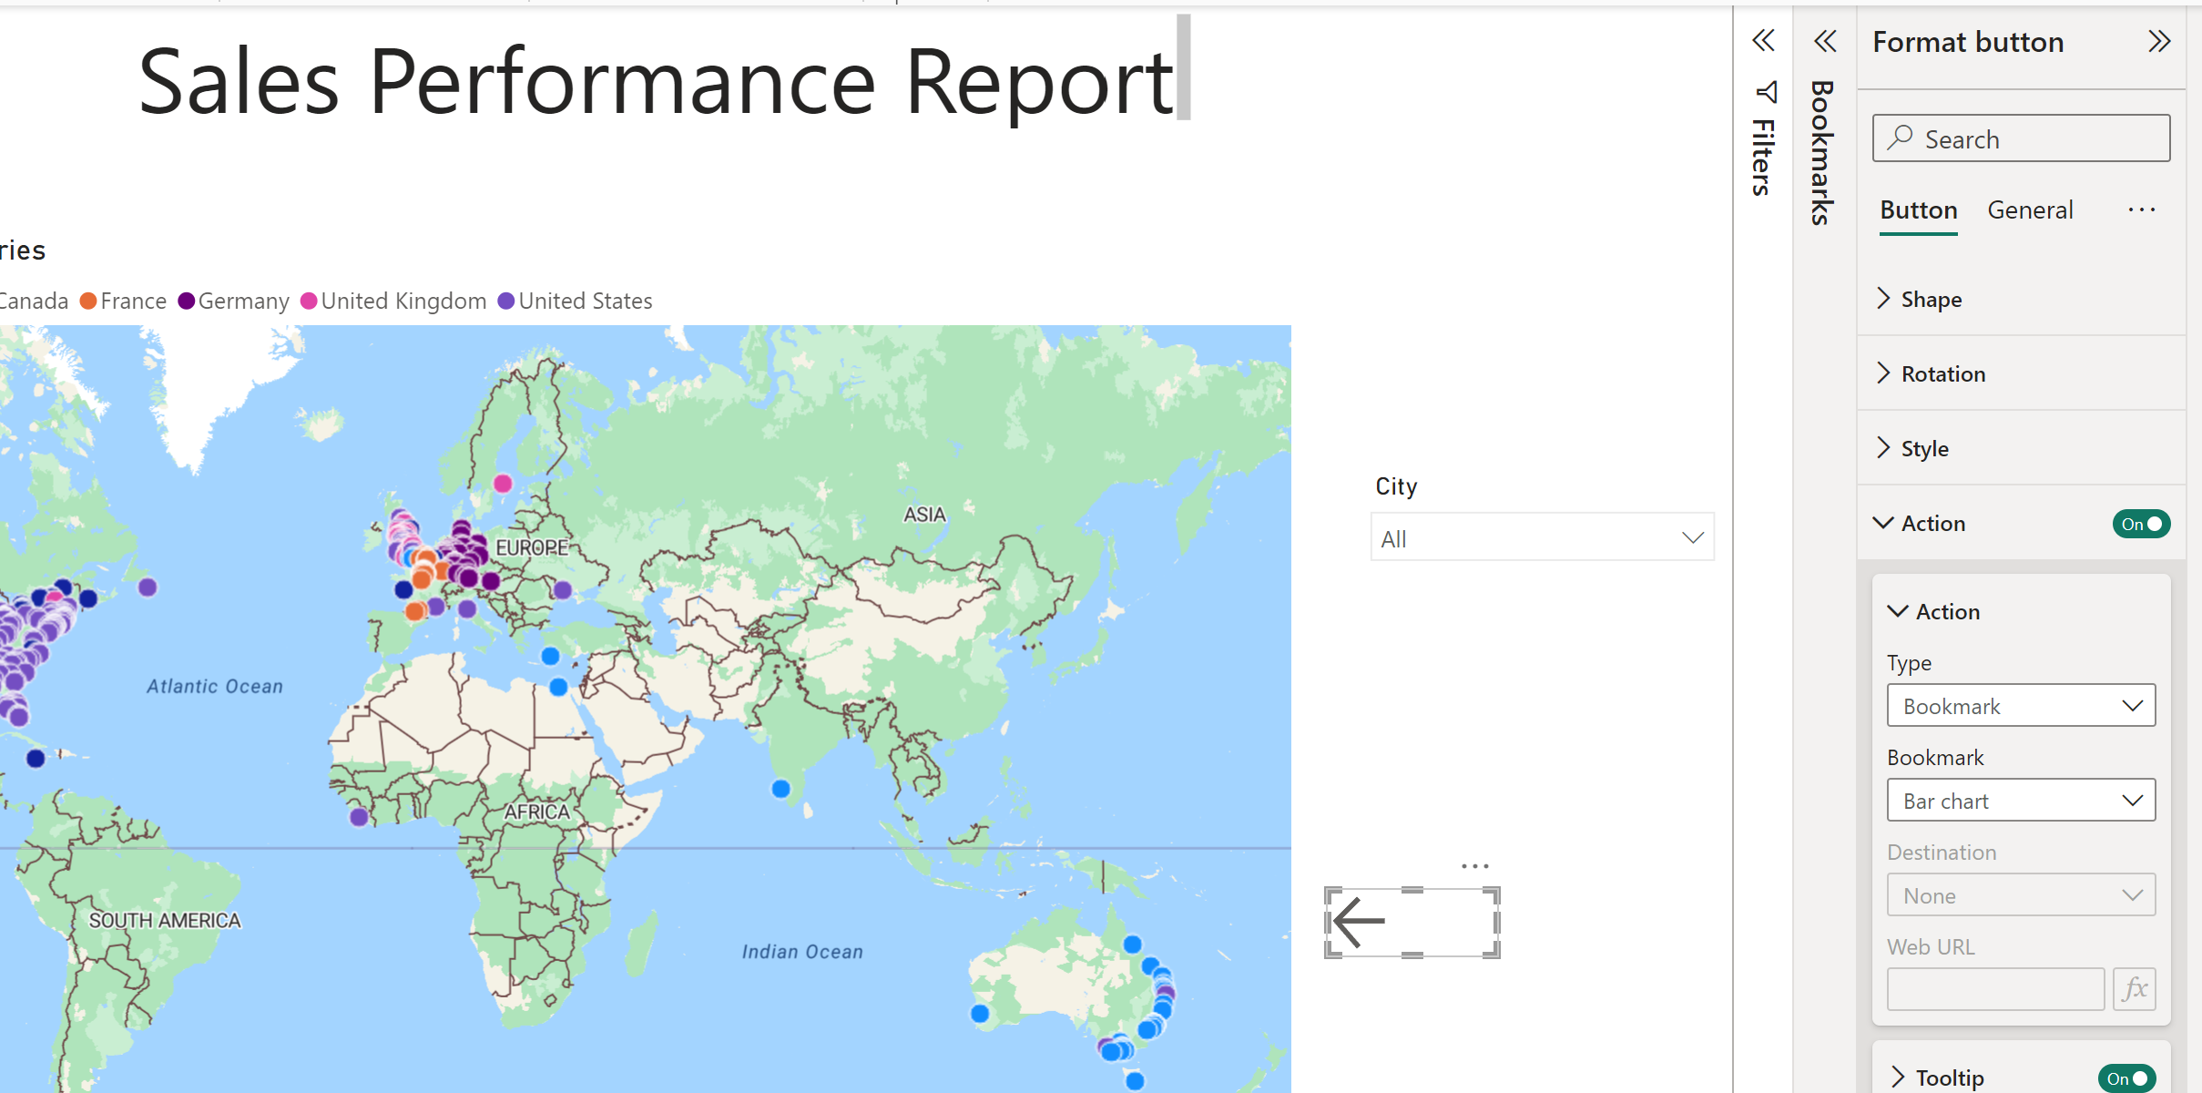
- TODO
- 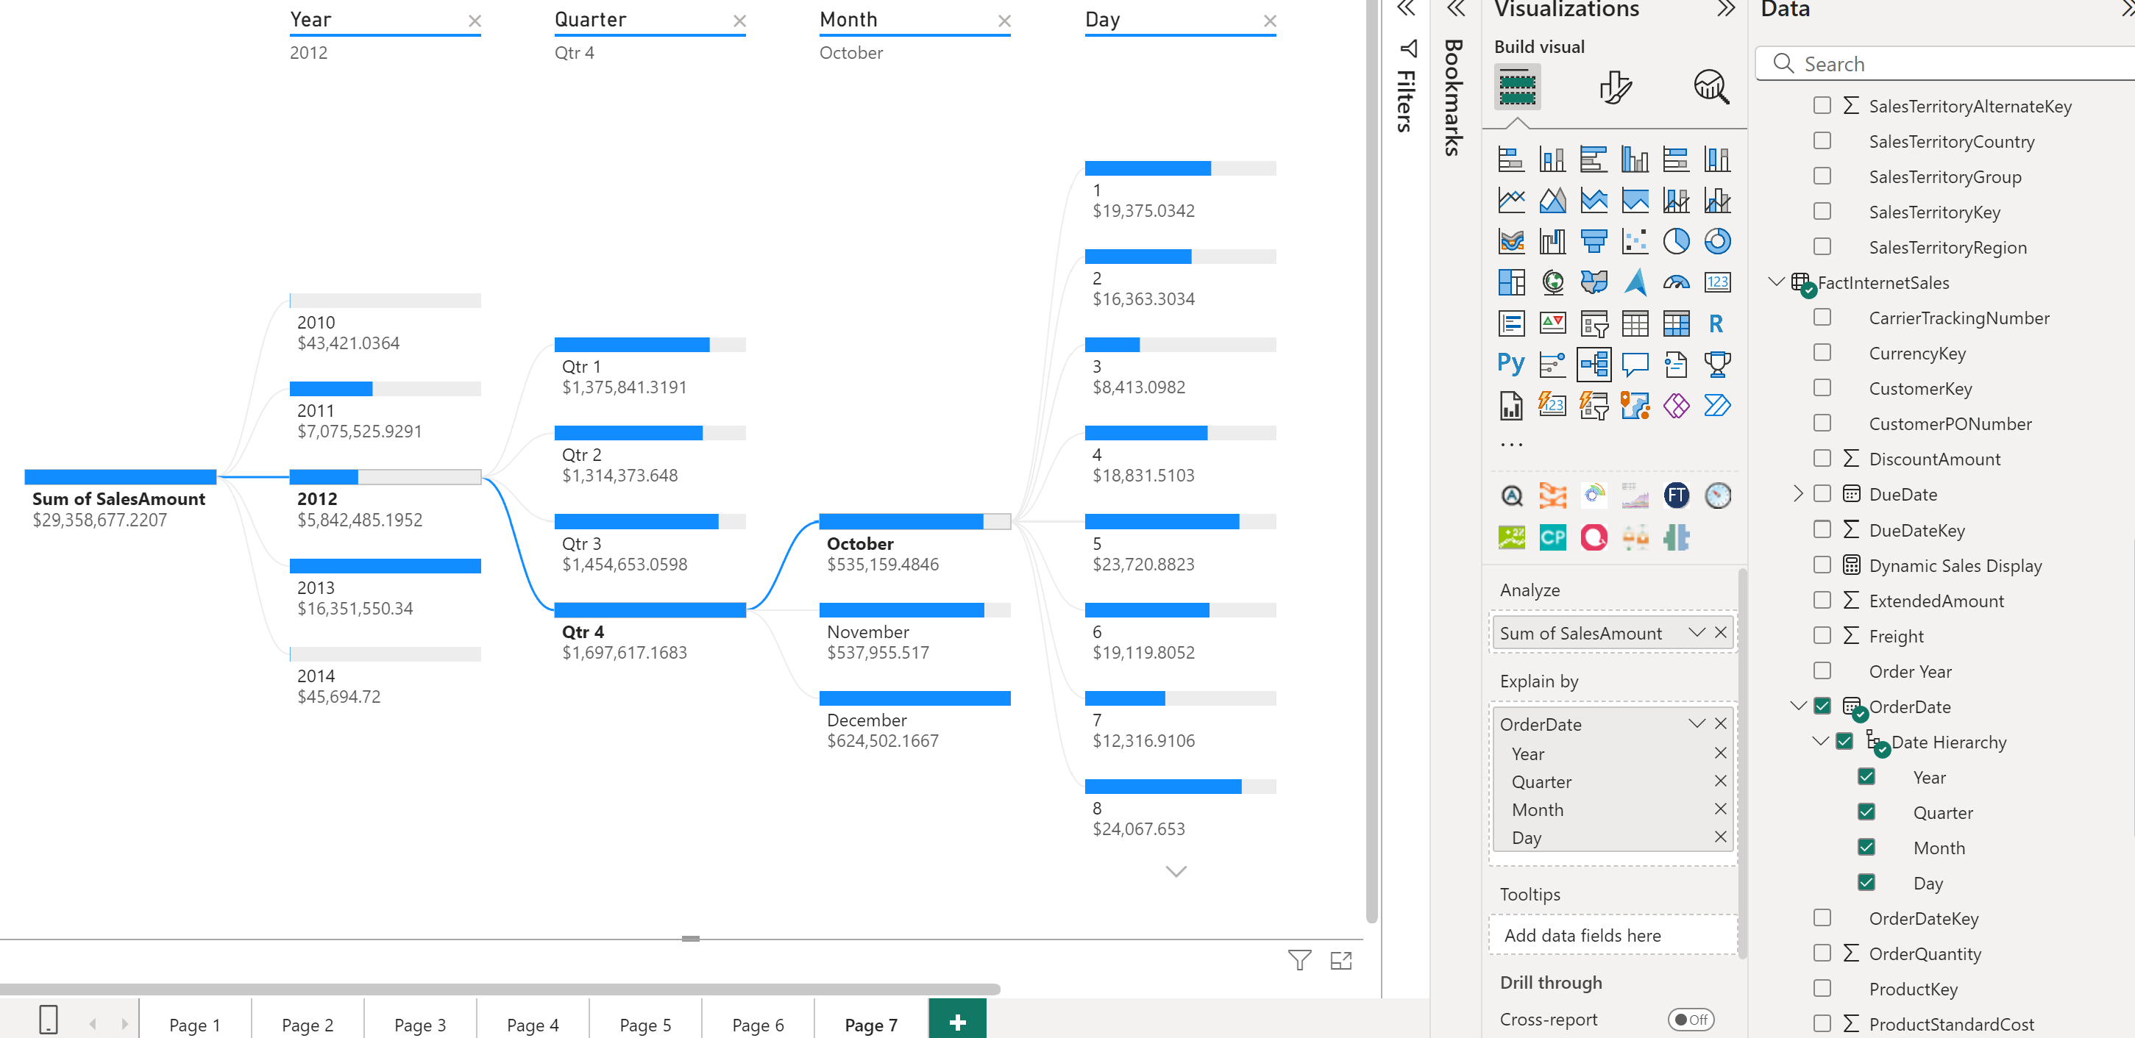 Drilled down sales amount in FactInternetSales by year quarter month day
- 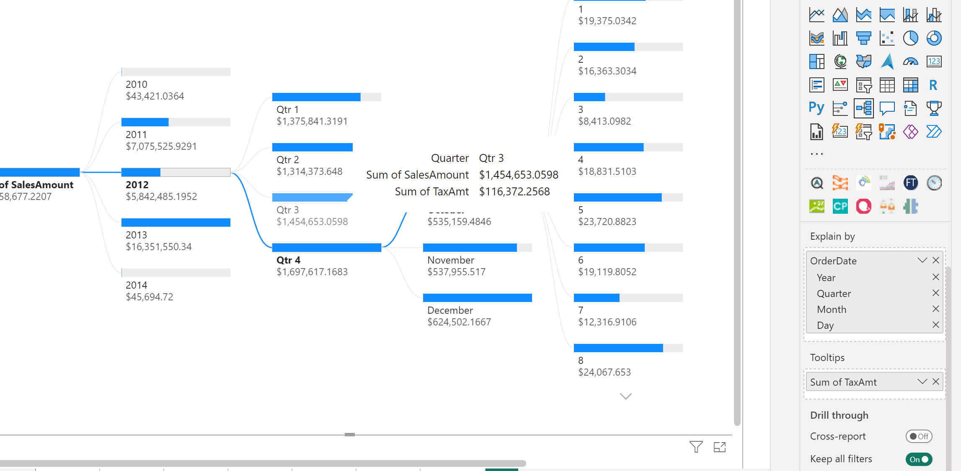 Showing total tax amount in tooltip

